Comparable systems

Whipsnade, Colchester, Chester and ZSL London Zoo are the main competitors to Claybrook Zoo, the main one being Whipsnade Zoo due to it being a popular zoo with millions of customers coming in and out and also becoming Whipsnade members, this also goes for the same for; Colchester, Chester and ZSL London Zoo.

I have researched all of these competitors and their websites and developed a table stating all of their key aspects to which makes them an outstanding Zoo along with them attracting many customers through their websites. The research is reflected through the table below shows the positive and negative attributes of the websites. In addition, the websites have been scored out of five with five being the most effective and one the least, the website features have been scored on usability, speed, colour schemes and many more.

**Whipsnade zoo**

This is the website for Whipsnade zoo which mainly focuses on giving out information about the zoo to the people who are visiting the system. When you first visit the website you are approached with a home page which has a slideshow of all the latest information.

| **Positive attributes** | **Negative attributes** |
| --- | --- |
| The homepage is spaced out clearly and easy to read and extract information | The bar above the zoo’s logo is too colourful and may confuse the user as the colour schemes to not associated with the headings that they lead to |
| Picture slides on the homepage give a glimpse of what is going on within the zoo such as events etc and is very informative to the potential customers and maybe some potential sponsorships | The background of the whole website is white which is plain, if parents show their kids this website they are not drawn into it, however if it had some colour it would |
| Social media links are right at the top when you visit the page, this can give the customers a quick and easy access on in hand information about the zoo and how it is now, this can be seen through Instagram or Facebook posts | There are two navigation bars on the homepage this confuses the user on where it will direct them to |
| Horizontal navigation bar makes it easier for the user to navigate around the website as it has its own subheadings on specific areas |  |
| Allows the user to sign up for email updates this is useful as it interacts with the user, if you want to join you can add your email address and you will be notified once everything is set in place and you are kept posted through your email |  |
| The website is up and running 24 hours and has no issues |  |
| Customers can purchase their tickets efficiently online under the title ‘’buy tickets’’ on the navigation bar which is very useful for the users as it does not consume time on spending most of the time trying to search where to buy the tickets |  |

**Colchester zoo**

**

image two

| **Positive attributes** | **Negative attributes** |
| --- | --- |
|  |  |
| Once you approach the website you are notified with an important update which states all the important information the user needs to take in before continuing **(image 2)** | Social media links that are on top of the main navigation bar are not as noticeable due to the colours used |
| The important update includes FAQ’s which is attached to a hyperlink and takes you to the page with no problems as it loads straight away once clicked | There are a lot of buttons on the homepage which can be a bit daunting for the user as it is crowded and may confuse the user on what they have to click on the get information up |
| Video slideshow on the homepage this makes it engaging with the younger generation as it is visual |  |
| Drop down navigation bar makes the accessibility easier for the user |  |
| Zoo themed colour theme, this reflects a warm and friendly environment at the zoo |  |

**Chester zoo**

| **Positive attributes** | **Negative attributes** |
| --- | --- |
| Welcoming homepage, seen in the image above, this implies to the user that the zoo is friendly | The navigation bar is too close to the slides on the homepage which makes it overwhelming for the user as the font and colours are very similar |
| colour and professional homepage unlike the other webpages, this makes more customers on board to come to the zoo due to the professionalism shown on the webpage | Pictures on the slideshow covers the circles the user chooses to navigate themselves onto the next picture on the homepage |
| colours that are on the website are seen as child friendly, this makes children more engaged and attracted to the page |  |
| The user can specially search for what they want by clicking on the magnifying glass right next to the drop down navigation bar |  |
| Once you go on the homepage you can take a quiz this is appealing for families to do together and attracts their target audience to come together |  |
| Book your tickets icon is colourful from the rest, this makes it quick and efficient for the user to book their tickets, also while you are at it you can sponsor an animal, this increases the zoo’s profit which we can use for the Claybrook zoo |  |

**ZSL London Zoo**

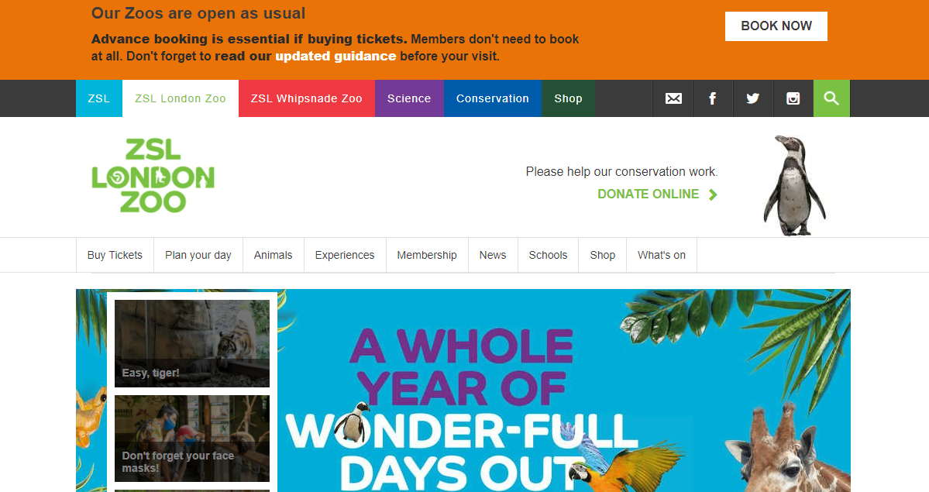

| **Positive attributes** | **Negative attributes** |
| --- | --- |
| Slide show on homepage lets the user take control such as going back and forth onto the slides | Navigation bars may confuse the user as there are two, it may lead them to not navigate affectively |
| Colourful navigation bar attracts younger target audience | Background colour of website is plain not as colourful as other competitor’s websites |
| Latest information about safety keeps customers safe and shows that customers are their priority | There is no login section for users to access and see their history purchases etc |
| A map on how to get to the zoo for those who are travelling to get to the zoo |  |
| Zoo updates on website such as they announce new animals being born |  |
| F&Q’s answered and publicly displayed onto the website |  |
|  |  |

**Comparison of features on the competitor zoo websites**

1 – inadequate 2- Poor 3 – Average 4-Very good 5-Excellent

| **Feature** | **Whipsnade Zoo** | **Colchester Zoo** | **Chester Zoo** | **ZSL London Zoo** |
| --- | --- | --- | --- | --- |
| Usability | 4 | 4 | 5 | 4 |
| Layout | 4 | 4 | 5 | 3 |
| Speed | 4 | 4 | 4 | 4 |
| Navigation | 3 | 5 | 4 | 3 |
| Colour Scheme | 3 | 5 | 5 | 3 |
| Images | 3 | 3 | 5 | 4 |